SUBCOURSE EDITION
AV0900 7

U.S.ARMY AVIATION CENTER



LOCATE COORDINATES

ON

AERONAUTICAL CHARTS

THIS SUBCOURSE HAS BEEN REVIEWED FOR
OPERATIONS SECURITY CONSIDERATIONS.

US ARMY CORRESPONDENCE COURSE

AVIATION SUBCOURSE 0900*

LOCATE COORDINATES ON AERONAUTICAL CHARTS

CONTENTS

Frame Page

INTRODUCTION iii

LESSON: TASK 011-149-0001, LOCATE A GEOGRAPHIC COORDINATE
ON A SECTIONAL CHART, JOINT OPERATIONS GRAPHIC
(AIR)(JOGA), OR TACTICAL PILOTAGE CHART (TPC). 1

Latitude and Longitude 1 3

Geographical Grid System 8 4

PRACTICE EXERCISE 19

PRACTICE EXERCISE ANSWERS . 20

EXTRACT OF JOGA (Inside back cover)

*Supersedes Aviation Subcourse 0900, Edition 6.

i

This page Intentionally left Blank

ii

INTRODUCTION

This subcourse, part of the Flight Operations Coordinator (Skill Level 1) course, teaches you how to determine the geographic coordinates of a specific location on an aeronautical chart. It supports STP 1-93P1-SM and can be used as a study reference for Task 011-149-0001.

* * * IMPORTANT NOTICE * * *

THE PASSING SCORE FOR ALL ACCP MATERIAL IS NOW 70%

PLEASE DISREGARD ALL REFERENCE TO THE 75% REQUIREMENT

Unless otherwise stated, whenever the masculine gender is used, both men and women are included.

iii

LESSON

TASK: 011-149-0001, Locate a Geographic Coordinate on a Sectional Chart, Joint Operations Graphic (Air) (JOGA), or Tactical Pilotage Chart (TPC).

OBJECTIVE: You will be able to determine specific geographic coordinates on an aeronautical chart.

CONDITION: Given a sectional chart (1:500,000), JOGA (1:250,000), or TPC (1:500,000) and a set of geographic coordinates to be plotted.

STANDARD: You must locate the geographic coordinates (longitude and latitude) on the sectional chart, JOGA, or TPC within ±30 seconds.

REFERENCE: FM 21-26 (Jan 69, with change 1).

TEXT

THE PROGRAMMED TEXT THAT FOLLOWS CONSISTS OF 14 FRAMES. READ EACH FRAME CAREFULLY, STUDY THE ASSOCIATED GRAPHICS, AND WRITE YOUR ANSWER IN THE SPACE PROVIDED. THEN CHECK YOUR ANSWER WITH THE SOLUTION AT THE TOP OF THE NEXT FRAME. IF YOUR ANSWER IS INCORRECT, TURN BACK TO THAT PARTICULAR FRAME, RESTUDY THE MATERIAL, AND CORRECT YOUR ANSWER. BEGIN WITH FRAME 1 AT THE TOP OF PAGE 3 AND CONTINUE THROUGH THE FRAMES ON THE RIGHT-HAND (ODD-NUMBERED) PAGES UNTIL GIVEN FURTHER INSTRUCTIONS.

1

LATITUDE AND LONGITUDE FRAME 1

Latitude and longitude are imaginary lines drawn on the globe of the earth and on charts. These lines form a grid by which the positions of various points or objects may be located accurately. The parallels of latitude extend around the globe or in the directions of ______________ and ______________. Meridians of longitude extend up and down the globe or in the directions of __________ and _________.

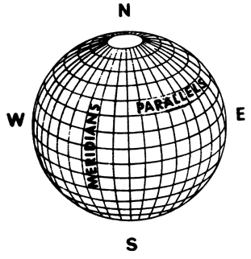

3

GEOGRAPHICAL GRID SYSTEM FRAME 8

If you could peel the grid off the globe and flatten it out, it would look something like this.

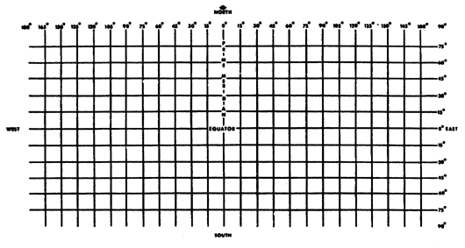

By numbering each parallel and meridian and using the references previously mentioned, you can determine any point on the earth's surface. This system is called the Geographical Grid System. When using the Geographical Grid System, a specified point or position is identified by the coordinates and is referred to as a ___________________ coordinate.

4

ANSWER 1

east, west; north, south

FRAME 2

Lines of latitude are called parallels. They are parallel to each other and to the equator. You should associate these key words with each other: ______________, _______________, and_______________.

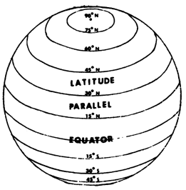

Lines of longitude are called meridians. They are not parallel but converge at the ____________ ____________ and ____________ ________________.

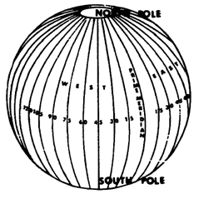

5

ANSWER 8

geographic

FRAME 9

Geographic coordinates are stated as so many degrees north or south of the equator and so many degrees east or west of the prime meridian. Fort Rucker is located about 30° N and 90° W. Oklahoma City is located NEAR ____________________________________________________________.

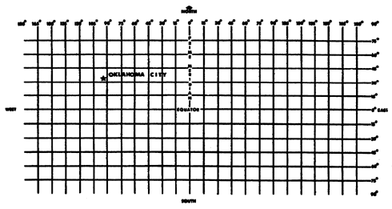

6

ANSWER 2

latitude, parallel, equator; North Pole, South Pole

FRAME 3

To locate a point on the earth's surface using the lines of latitude and longitude, you must have reference points. The lines drawn east and west on the globe are parallels of _______________ and use the __________________ as a reference. Latitude is a measurement, in degrees, of angular distance ____________________ or _______________________of the ____________________.

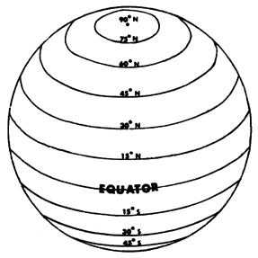

7

ANSWER 9

35° N and 95° W (approximate)

FRAME 10

Since meridians and parallels are circles and are divided into 360 degrees, a 1-degree measurement of the earth's surface will cover a very large area (as much as a 60-nautical-mile square). Needless to say, this is a large area for pinpointing the exact position of an aircraft or ship at sea.

To allow for more precise measurements, each degree is divided into 60 ___________and further divided into _______________. This is similar to the manner in which the hours of time are divided.

1 degree = _____________ minutes.

1 minute =_____________ seconds.

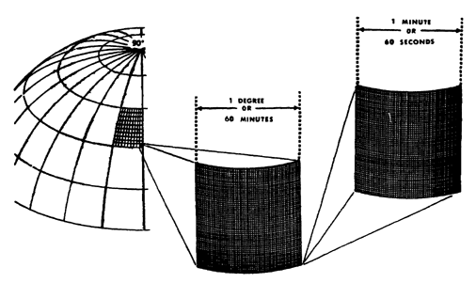

8

ANSWER 3

latitude, equator; north, south, equator

FRAME 4

The lines drawn north and south on the globe and charts are meridians of _______________________ and use the ____________ __________ as a reference. The prime meridian extends from the North Pole through the Naval Observatory in Greenwich, England, to the South Pole. Longitude is a measurement, in degrees, of angular distance __________or ___________ of the__________ _______________.

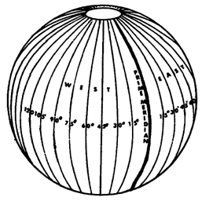

9

ANSWER 10

minutes, seconds; 60; 60

FRAME 11

The same symbols used to indicate feet (') and inches (") are also used for minutes and seconds.

The geographical location of the VHF omnidirectional range (VOR) station at Cairns Army Airfield is 31°16'08" N and 85°43'35" W. These coordinates tell you the VOR station is located 31 _______________ 16 _______________08 ________________north of the ____________________ and 85 ____________43 __________ 35 ___________ west of the__________ ________________.

10

ANSWER 4

longitude, prime meridian; east, west, prime meridian

FRAME 5

The equator divides the earth into the _______________ Hemisphere and the ________________ Hemisphere.

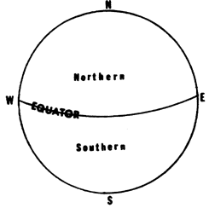

The prime meridian, along with the 180-degree meridian, divides the earth into the ____________-Hemisphere and the _________________________Hemisphere.

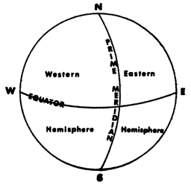

11

ANSWER 11

degrees, minutes, seconds, equator, degrees, minutes, seconds, prime meridian

FRAME 12

You learned in the previous frame that coordinates are usually expressed in degrees, minutes, and seconds; however, on aeronautical charts, only coordinates of degrees and minutes are numbered.

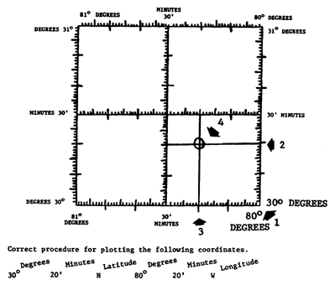

On the diagram above, locate the arrow numbered 1. It is pointing to the 30-degree latitudinal line that runs east and west (right to left) and the 80-degree longitudinal line that runs north and south (up and down). This is the starting point. Count up from that point along the 80-degree longitudinal line to the 20-minute mark. (Each tick mark equals one minute.) The 20-minute mark is located at Arrow 2. Count left along the 30-degree latitudinal line to the 20-minute mark. Arrow 3 is pointing to 20 minutes. A horizontal line has been drawn across the square from that point at 30°20' N latitude (Arrow 2). A vertical line has been drawn across the square from the point at 80°20' W longitude (Arrow 3). The intersection of the two lines (Arrow 4) is the location of latitude 30°20' N and longitude 80°20' W.

12

ANSWER 5

Northern, Southern; Western, Eastern

FRAME 6

The greatest number of degrees measured north or south of the equator would be _____ degrees north latitude or ______ degrees south latitude.

The greatest number of degrees measured east or west of the prime meridian would be _____ degrees east longitude or _________degrees west longitude.

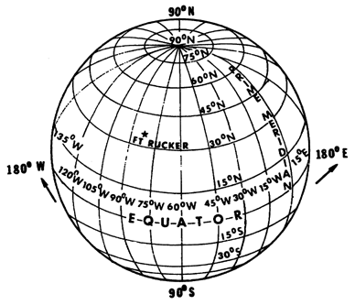

13

ANSWER 12

No response required.

FRAME 13

Airports are usually indicated on an aeronautical chart by a circle with an aerodrome symbol displayed in the circle. The symbol indicates the type of airport. See "AERODROMES (Military or Civil) " in the legend on the left-hand side of the JOGA extract provided in the back of this booklet.

In this frame and the next, as well as in the practice exercise and examination, you will determine geographic coordinates for airports depicted on this JOGA extract. These airports are indicated by numbered arrows. Plot the correct coordinates from the center of each airport.

The correct geographic coordinates for the airport denoted by Arrow 1 on the JOGA extract are which of the following?

a. 31°22' N and 85°28' W
b. 31°36' N and 85°08' W
c. 31°22' N and 85°18' N
d. 31°22' N and 85°18' W

14

ANSWER 6

90, 90; 180, 180

FRAME 7

Using the equator as a reference for the measurement of latitude and the prime meridian for the measurement of longitude, you can locate any point on the earth's surface by measuring north or south of the equator and east or west of the prime meridian.

The location of Fort Rucker on the map below is NEAR _____ ___________ latitude _________ _____________ ______________and longitude.

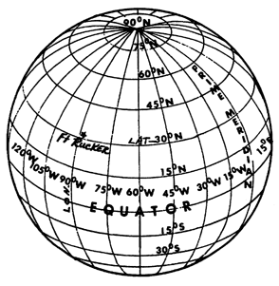

15

ANSWER 13

d. 31°22'N and 85°18' W

FRAME 14

The correct geographic coordinates for the airport denoted by Arrow 2 on the JOGA extract are which of the following?

a. 31°26' W and 85°37' N
b. 31°26' N and 85°37' W
c. 31°21' N and 85°37' W
d. 31°21' W and 85°37' N

16

ANSWER 7

30 degrees north, 90 degrees west

TURN TO PAGE 4 FOR FRAME 8. CONTINUE WITH THE FRAMES ON THE LEFT-HAND (EVEN-NUMBERED) PAGES.

17

ANSWER 14

b. 31°26' N and 85°37' W

THIS CONCLUDES THE LESSON. NOW COMPLETE
THE PRACTICE EXERCISE ON THE NEXT PAGE.

18

PRACTICE EXERCISE

REQUIREMENT: Solve the following by filling in the blanks:

1. Parallels of latitude extend __________________and ____________________.

2. Meridians of longitude extend _________________and ___________________.

3. Starting from the prime meridian, meridians are numbered by their angular distance east to _______ ______________ and west to _________ _______________.

4. Geographic coordinates are stated relative to reference points which are the ___________and the___________ ________________.

5. The latitude of a point on the earth's surface is expressed in ____________, _____________and ___________; the longitude is expressed in, _______________ ______________, and_____________.

6. Each degree is divided into _________________ minutes.

REQUIREMENT: Using the extract of the JOGA provided, solve the following by selecting the correct answers:

7. The correct geographic coordinates for the airport denoted by Arrow 3 are

A. 30°44' N and 84°43' W.
B. 31°34' N and 85°48' W.
C. 31°34' N and 85°43' W.
D. 31°44' N and 85°48' W.

8. The correct geographic coordinates for the airport denoted by Arrow 4 are

A. 51°07' N and 84°48' W.
B. 31°17' N and 85°43' W.
C. 30°17' N and 84°43' W.
D. 31°07' N and 85°43' W.

19

PRACTICE EXERCISE ANSWERS

1. east, west (Frame 1)

2. north, south (Frame 1)

3. 180 degrees, 180 degrees (Frames 5 and 6)

4. equator, prime meridian (Frame 9)

5. degrees, minutes, seconds; degrees, minutes, seconds (Frame 10)

6. 60 (Frame 10)

7. D. (Frame 12 and JOGA extract)

8. B. (Frame 12 and JOGA extract)

